In order to successfully create and consume HTTP Services, you must know some basics about the HTTP Protocol and architecture. I’m sure you have seen HTTP before, in fact, whenever you browse to any website over the World Wide Web, such as Revature, it’s using the HTTP Protocol.

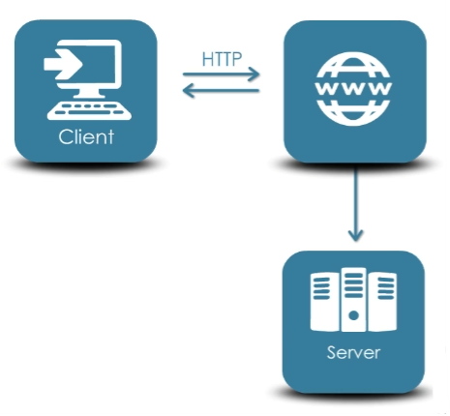

The World Wide Web uses the HTTP Protocol to send data such as HTML files and images from your browser, to the web server, and vice versa.

HTTP uses a client/server based architecture, where the client is your web browsers, search engines, etc., and the server is the web server the web site is hosted on.

There are three basic features that make HTTP a simple but powerful protocol:

HTTP is connectionless. When you send a request to a server, your browser actually disconnects from the server and waits for a response. The server will then process the request, and re-connects back to your browser to send a response back.

HTTP is media independent, so you can send whatever data or data type you want over HTTP as long as the server and the client know how to handle the data. Keep in mind both the client and the server both need to specify what type of data is being transmitted. The server and client are aware of each other only during a current request.

HTTP is stateless. So we mentioned HTTP is connectionless, and it is a direct result of HTTP being a stateless protocol. The server and client are aware of each other only during a current request. After the request they pretty much forget about each other